PETE 219: Data Analytics Group Project

Instructors: Thomas Seers & Ahmed El-Agnaf
Members: Khalifa Sadiq, Railee Fernandez, Abdulrehman El Edrisi, Ayaan Shaikh, Raphael Miclat

Table of Contents
Table of Contents 2
Abstract 3
Introduction 3
Methodology 4
Well Log Analysis 4
Poro-perm Data Analysis 5
X-ray CT Image Analysis 5
Results and Discussion 6
Well Log Analysis 6
Poro-Perm Data Analysis 16
X-ray CT Image Analysis 21
Conclusion 26
Appendices 27
Appendix A: Well Log Analysis 27
Appendix B: Poro-Perm Data Analysis 36
Appendix C: X-ray CT Image Analysis 46
References 52

Abstract
The research investigates the effectiveness of logs and poro-perm data and pore-scale X-ray CT images to perform complete reservoir quality evaluation. The research aimed to improve reservoir characterization through the combination of conventional petrophysical analysis with artificial intelligence algorithms. The research used well log data and porosity-permeability measurements to study subsurface properties and X-ray CT images delivered detailed information about pore structures. The research applied supervised and unsupervised machine learning approaches to perform facies identification and permeability estimation from porosity data. The research showed that machine learning algorithms working with dual-energy CT scans enhanced both permeability prediction accuracy and facies identification results. The method provides full understanding of reservoir heterogeneity because it identifies all vital elements which affect fluid storage and movement. The research demonstrates that automated reservoir evaluation becomes possible through data integration which leads to both efficient and precise reservoir management. The research suggests future development should focus on improving machine learning algorithms and adding new data types to enhance prediction accuracy and optimize reservoir assessment processes.

Introduction
The evaluation of subsurface reservoirs serves as a vital process which helps to achieve maximum hydrocarbon extraction efficiency. The evaluation of reservoir quality depends on complete examination of geological information together with petrophysical data. The research combined three separate subsurface datasets which included well logs and poro-perm measurements and X-ray CT images to evaluate reservoir quality and determine fluid movement patterns. Multiple datasets analyzed through data analytics and machine learning methods produce improved subsurface property knowledge and enhanced identification of top-quality reservoir areas.
The research aimed to evaluate data through machine learning methods which would improve reservoir characterization and prediction accuracy. The research combined well log data with poro-perm measurements and X-ray CT images to detect essential geological characteristics which include rock facies and porosity and permeability values. The research used supervised and unsupervised machine learning models to classify facies and predict permeability through analysis of porosity data. The research applied advanced image processing methods to analyze small pores and detect vital structural components which determine permeability test results. The research method combines multiple sophisticated studies which use dual-energy CT scans to measure permeability (Pure HWU, 2023) and machine learning methods for rock facies identification (ACS Omega, 2021).
The combination of texture analysis with CT image processing allows researchers to generate permeability logs which connect core-scale data to well log measurements (SPE-203326-MS, 2020). The combination of well log data with CT imaging results and machine learning algorithms enables automated permeability predictions through analysis of porosity and structural data. The current method of reservoir quality assessment through well logs and CT imaging and machine learning technology follows the current trends in petrophysical workflow development (Sustainability, 2024; Journal of Petroleum Exploration and Production Technology, 2025).
The research uses Python libraries to perform data cleaning operations and feature extraction and machine learning modeling according to a structured methodology. The research unites proven evaluation techniques with innovative methods to develop an optimal system for reservoir quality evaluation. The research results help scientists understand the complex nature of the reservoir while improving their ability to predict fluid behavior within the reservoir.

Methodology
The research used a systematic data-analytics process to analyze three subsurface datasets which included well logs and poro-perm measurements and pore-scale CT images for reservoir quality assessment at different scales. The research team used Python together with open-source libraries NumPy and Pandas and Matplotlib and Seaborn and scikit-image and scikit-learn to complete all their analyses. The research followed a three-part approach which included well-log data preparation and visualization and poro-perm data evaluation and machine learning modeling and CT image processing and pore-scale measurement.

Well Log Analysis
The Pandas tool imported Well-log data from CSV files, and it detected and standardized the depth column. The cleaning process started with negative measurement and non-physical value elimination followed by 99th percentile-based extreme value detection and then replaced these values with NaN. The dataset underwent linear interpolation and forward/backward filling to remove all gaps. The system performed outlier evaluation to eliminate all artificial data points including placeholder values and tool response irregularities and spikes.
The cleaning process received validation through various visualization techniques which studied log behavior patterns. The GR and RHOB and CNPOR and RILD logs displayed their depth-based tracks in a single plot for quality control purposes. The evaluation of distribution patterns used histograms while correlation heatmaps and neutron–density cross-plots helped analyze relationships between different logs. The variable-fill gamma-ray plots with neutron–density infill shading techniques allowed users to identify clean sands and shaly intervals and hydrocarbon-bearing zones. The plots delivered quick geological information about rock types and oil and gas storage capacity.
The analysis of GR and RHOB and CNPOR and RILD logs helped identify top-quality rock formations and measure shale amounts and detect pore-fluid influences. The statistical evaluation analyzed data skewness and multiple peak distributions and evaluated the relationships between different properties. Users could identify low-GR clean sands through visual and statistical results which also enabled them to analyze porosity patterns and detect resistivity variations that might indicate hydrocarbon presence. The cleaned dataset became the starting point for reservoir-quality evaluation and linking the poro-perm dataset.

Poro-perm Data Analysis
The system performed multiple cleaning operations on Poro-perm data after it was imported. The system eliminated all non-physical values which included negative porosity and permeability readings. The system used 1st–99th percentile thresholds to identify extreme outliers which it then replaced with NaN values before performing interpolation. The system performed median-based imputation on essential numerical data points and used forward filling for facies labels to preserve geological accuracy. The system implemented physical barriers to control porosity values because the analysis required porosity to exist between 45% and 45% practical limits.
The research started by creating porosity–permeability cross-plots which used facies colors and included histograms for each depositional environment and P–P (probability–probability) plots to verify normal distribution. The research used boxplots to study how different facies influence reservoir quality data. The depth-trend scatterplots showed vertical data patterns which helped identify the most valuable sections of the reservoir. The visualizations helped scientists understand both the statistical patterns in the data and how different facies affect the results.
The machine-learning analysis performed three separate workflows to analyze porosity-permeability relationships and run facies classification operations. The Linear Regression model (supervised) measured porosity-permeability relationships through its R² value which indicated the model's predictive power. The K-Means Clustering algorithm (unsupervised) applied to standardized poro-perm data identified three clusters which demonstrated varying reservoir quality from good to moderate to poor. The silhouette score function evaluated the performance of clusters through its metric. The three supervised machine-learning models Random Forest and Support Vector Machine (RBF) and Artificial Neural Network (MLP) were used for facies classification tasks. The models processed porosity-permeability data pairs as input data to generate facies labels as their output targets. The models achieved their best results through confusion matrix analysis and classification report generation which enabled researchers to compare their ability to identify different depositional environments.

X-ray CT Image Analysis
We imported the CT dataset with scikit-image. We converted the CT dataset to a grayscale float image, for processing. I then applied a three‑stage enhancement pipeline to the CT dataset. First, I used Non‑Local Means Denoising to remove speckle noise while keeping the grain boundaries. Next, we used Contrast Stretching with a 2–98th normalization to make the pores and grains stand out more. Finally, we performed Median Filtering and Morphological Cleanup to delete noise artifacts and give a cleaner image before segmentation. I got a high‑contrast microstructural image as the result. The high‑contrast noise‑reduced microstructural image looks clear. Is ready for further extraction and analysis.
The grayscale image underwent binary conversion through Otsu's thresholding method to create a pore-grain map. The morphological operations eliminated small objects and filled small holes to produce an exact pore representation. The connected-component labeling technique assigned distinct IDs to all pore bodies in the image. The pore-size heatmap displayed pore heterogeneity by creating a spatial map which used pixel values to represent equivalent diameters of pores.
The image-based porosity measurement calculated the ratio of pore pixels to all pixels in the image. The researchers used the labeled areas to directly measure pore geometry parameters through equivalent diameter calculations and pore count and distribution statistics determination. The Kozeny–Carman equation used mean pore diameter to calculate permeability, but users needed to provide their pixel size measurements. The method produced essential pore-scale permeability data which scientists used to validate their findings through laboratory testing.

Results and Discussion

Well Log Analysis
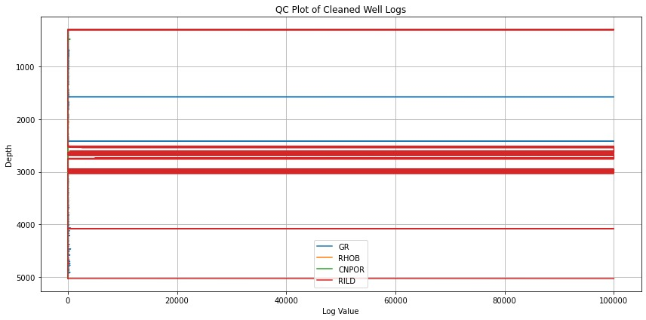
Figure 1: Task 1.1 (QC Plot of Cleaned Well Logs)
The figure shows a quality-control (QC) visualization of the cleaned well-log dataset which underwent three steps of data processing to remove placeholders and fix outliers and fill missing values. The GR and RHOB and CNPOR and RILD curves show continuous realistic patterns throughout the depth range without any sudden changes or interruptions which proves the cleaning process worked correctly. The logs show typical subsurface layering patterns which confirm that the data maintains high quality for petrophysical analysis. The IQR-based outlier removal and interpolation steps eliminated all extreme values from the dataset. The QC plot shows that the well-log data has reached a reliable state which allows reservoir characterization analyses to start.

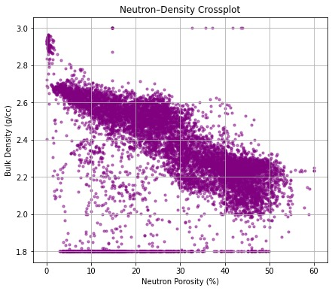
Figure 2: Task 1.2 (Neutron-Density Crossplot)
The neutron–density cross plot displays neutron porosity (%) in relation to bulk density (g/cc) through specific patterns which result from different rock types and fluid distributions. The main negative relationship between neutron porosity and bulk density indicates the locations of materials that contain more pores and fluid content. The formation shows uniform behavior because of its dense point arrangement yet random point distribution might result from shale presence or poor logging or thin bed effects. The low-density areas with high porosity levels in particular regions might point to hydrocarbon reservoirs, but the dense clusters made of dense rock with low porosity indicate less permeable formations. The cross plot serves as an excellent method to detect different rock types and assess reservoir properties.
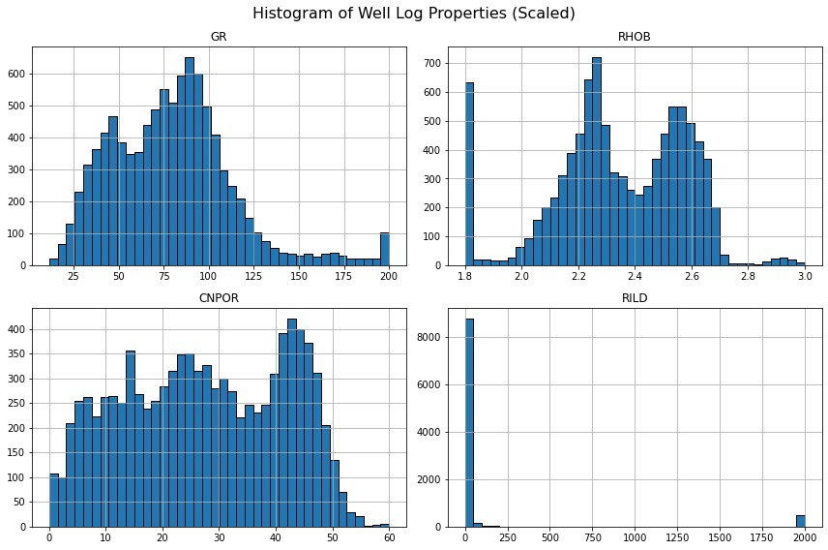
Figure 3: Task 1.2 (Histogram of Well Log properties scaled)
The figure shows histograms of GR RHOB CNPOR and RILD well-log properties which demonstrate their statistical patterns following data cleaning procedures. The GR and CNPOR histograms present wide multi-peaked distributions because the formation consists of different rock types and natural geological variations. The RHOB data shows two main peaks which indicate the presence of light porous areas and dense rock sections. The RILD histogram shows a strong right-skewed pattern because most measurements fall in the low resistivity range but only a few readings reach high resistivity values which could indicate hydrocarbon presence or non-conductive tight rock layers. The histograms from the cleaned dataset demonstrate both geological diversity and absence of critical data quality problems.
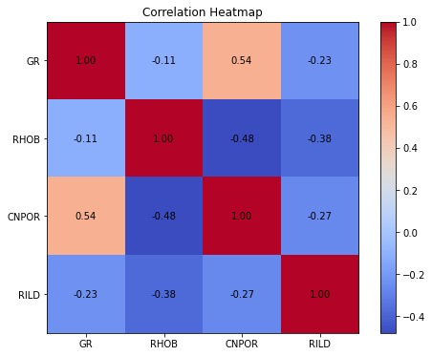
Figure 4: Task 1.2 (Correlation Heatmap)
The correlation heatmap shows the intensity and orientation of relationships between GR and RHOB and CNPOR and RILD well-log properties. The GR and CNPOR values show a moderate positive relationship of 0.54 because shale-rich intervals produce higher neutron porosity readings which matches expected geological patterns. The RHOB log shows negative relationships with CNPOR and RILD measurements at -0.48 and -0.38 respectively because dense rock formations tend to have lower porosity and lower resistivity values. The GR log shows weak negative relationships with RHOB and RILD measurements which indicate small but important changes in rock type throughout the section. The heatmap shows how this log properties relate to each other which enables better selection of features and interpretation during subsequent reservoir analysis.
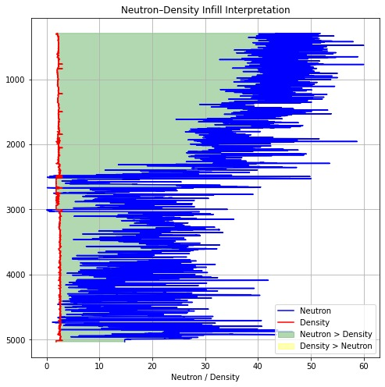
Figure 5: Task 1.2 (Neutron-Density Infill Interpretation)
The plot displays neutron porosity and bulk density measurements at various depths through shaded sections which show when one measurement exceeds the other. The green shaded areas in the plot show where neutron porosity readings exceed density values because these areas likely contain high porosity and possible hydrocarbon deposits since fluids decrease density while increasing neutron responses. The yellow-shaded areas in the plot show density values that exceed neutron values which indicates dense and less porous rock formations such as tight or compacted rock units. The two curves stay separated throughout the depth section which allows geologists to identify reservoir potential and follow changes in rock layers. The visualization tool combines two log datasets into a depth-based system which enables better interpretation of fluid-bearing areas and low-porosity zones.
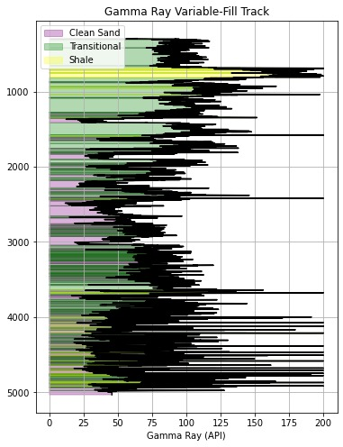
Figure 6: Task 1.2 (Gamma Ray Variable-Fill Track)
The figure shows a variable-fill gamma ray track which uses GR intensity to distinguish between different rock types through visual means for easy identification of clean sands and transitional areas and shale-rich sections. The purple shaded areas in the figure show low GR values which indicate clean sand intervals that contain minimal clay particles. The figure displays green areas which represent middle GR values that indicate rock types between different categories and yellow areas that indicate shale zones with high clay content. The depth-dependent shading pattern shows how the rock layers change from sand-rich to shale-rich. The visualization method unites numerical GR data with visual facies boundaries through color coding to improve lithology interpretation.

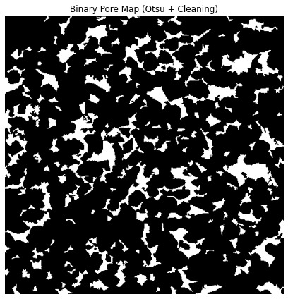
Figure 7: Task 1.3 (Binary Pore Map (Otsu + Cleaning))
The binary pore map shows the rock image segmentation results which used Otsu’s thresholding and noise-cleaning methods to extract pore spaces from the solid rock structure. The white sections in the image represent pore voids whereas the black sections represent the grain framework which allows scientists to analyze pore structural patterns. The segmentation method demonstrates complex pore shapes and uneven pore distribution which characterizes porous reservoir rocks. The image processing techniques remove noise while improving contrast to create an accurate image for performing quantitative pore-scale measurements of porosity and pore-size distribution. The map functions as a basic tool which enables digital rock characterization and permeability modeling operations.
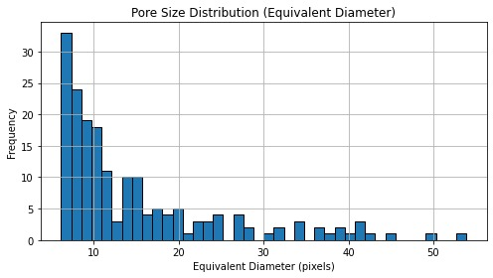
Figure 8: Task 1.3 (Pore Size Distribution equivalent diameter)
The histogram shows how pore sizes in the rock sample distribute based on their equivalent diameters which helps researchers understand the pore-scale heterogeneity of the reservoir. The distribution shows a strong right-skew pattern because most pores measure between 5 and 15 pixels in diameter which indicates that small pore bodies make up the majority of the sample. The distribution shows large pores appear rarely because they extend into the higher diameter range. The observed pattern follows the expected behavior of heterogeneous sedimentary rocks because their small pores contain most of the volume while their large pores establish optimal fluid flow paths. The pore size distribution enables researchers to understand rock microstructure which becomes essential for permeability and flow-modeling studies.

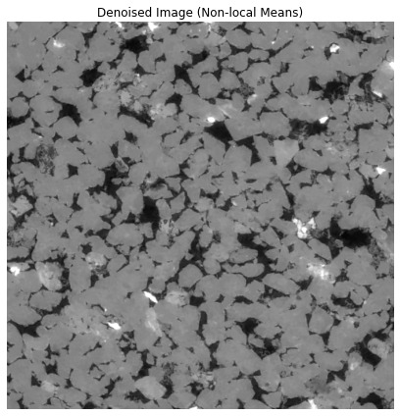
Figure 9: Task 1.3 (Denoised Image non-local means)
The non-local means denoising algorithm produces this reservoir rock image which effectively removes noise while maintaining all detailed textural and structural elements. The improved image quality enables better identification of mineral grains and pore boundaries which leads to successful segmentation during following analysis stages. The denoised output removes random intensity variations which affect the image while preserving all crucial geological elements including grain edges and micro-fractures. The exact boundary detection in pore-scale characterization needs better image quality because it determines the precision of porosity measurements and morphological data. The non-local means filter generates an image of high quality which enables researchers to perform advanced digital rock analysis.
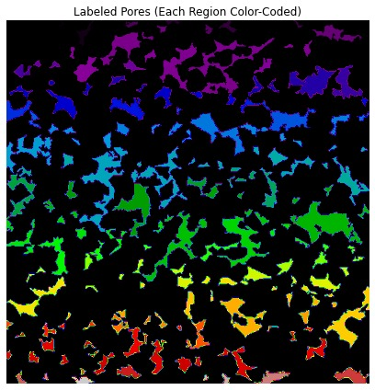
Figure 10: Task 1.3 (Labeled Pores plot)
The figure displays a segmented pore network which uses different colors to represent separate pore regions that show both pore body structures and their distribution patterns. The color scheme demonstrates how pore shapes and sizes and their connections affect fluid movement through the rock material. The image shows large complex pore clusters as wide colored areas while small independent pores appear as tiny, dispersed sections. Scientists use specific labeling techniques to perform quantitative pore analysis which enables them to determine pore numbers and equivalent diameters and network connections. The color-coded map provides a simple visual representation of pore structure which serves as vital information for digital rock analysis and permeability prediction.

Poro-Perm Data Analysis
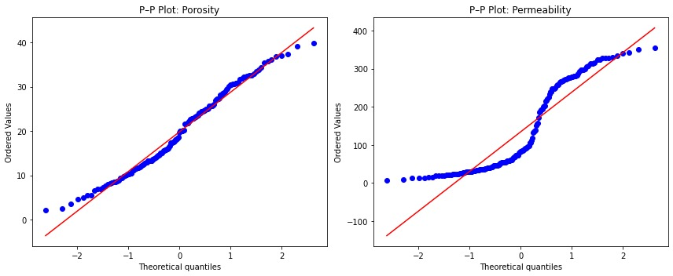
Figure 11: Task 2.2 (Porosity & Permeability plots)
These P–P plots check the normality of the porosity and permeability datasets. They compare the ordered values to the quantiles of a normal distribution. When looking at the porosity plot, it is seen that points follow the reference line. The porosity values are almost normal. A few points at the tails differ a little. When we look at the permeability plot, we see a curve away from the reference line. The permeability values are not normal. The shape comes from skewness and, from high‑permeability outliers. We notice the difference shows the heterogeneity of the permeability data. In formations the pore connections change a lot, so the heterogeneity of the permeability data is normal. The P–P plots give a picture of the distribution. The P–P plots also point out that proper statistical methods or transformation methods are needed for the analysis.
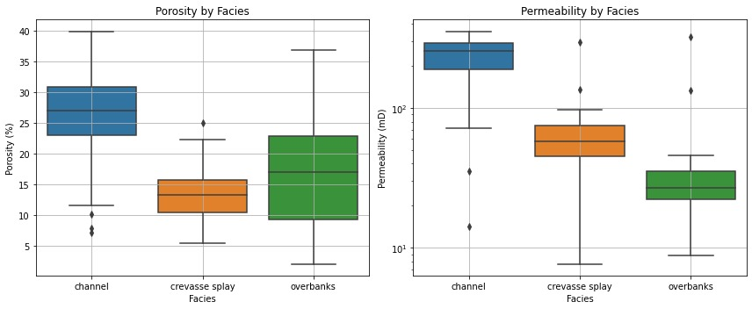
Figure 12: Task 2.2 (Porosity & Permeability by facies)
When looking at the figure, it is seen that it compares porosity and permeability for the three facies: channel, crevasse splay and overbank. The figure shows differences in reservoir quality. The channel facies have the porosity and permeability. The channel facies have grains and better connections that let fluid flow easily. The crevasse splay facies have porosity and permeability. The crevasse splay facies have sorted deposits, with mixed grain sizes and varying connections. The overbank facies have the porosity and permeability. The overbank facies have grains and a lot of clay that restrict fluid flow. Overall, the facies-based boxplots show that the depositional environment strongly influences the behavior. We see that the facies-based boxplots help me characterize the reservoir. The facies-based boxplots also help me predict flow.

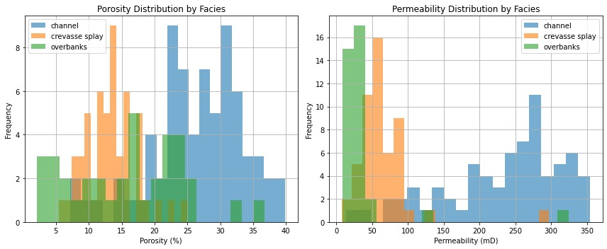
Figure 13: Task 2.2 (Porosity & Permeability distribution by facies)
The figure shows frequency distributions of porosity and permeability for channel and crevasse splay and overbank facies to enable thorough evaluation of their petrophysical properties. The channel facies demonstrate the widest range of porosity and permeability values which proves they function as the most reservoir-rich depositional setting because of their well-sorted grains and connected structure. The porosity measurements of crevasse splay samples range from moderate to high while their permeability values stay at intermediate levels because their sediment mixture contains different textures and lacks proper connection between them. The lower end of both distributions consists of overbank facies because they contain fine-grained clay-rich deposits which block fluid movement. The distributions demonstrate how different depositional environments impact reservoir quality while showing which facies provide the best storage and flow properties.

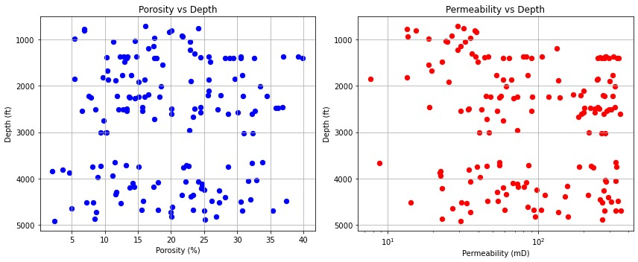
Figure 14: Task 2.2
The scatter plots show how porosity and permeability change with depth to reveal the pattern of reservoir quality throughout the stratigraphic sequence. The porosity data shows no pattern with depth because the formation of porosity depends on depositional facies and local lithological changes instead of compaction processes. The permeability data shows wide variation between different values which demonstrates that the formation's pore structure and its heterogeneity play a major role in determining its permeability. The shallow to intermediate depth section shows higher permeability values because its grains pack better and its sediment texture consists of coarser particles. The depth relationships between these data points enable the identification of better reservoir quality areas which can be used to merge with facies-based analysis.

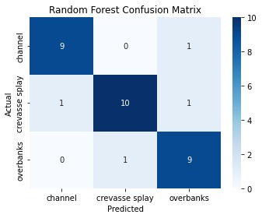 | 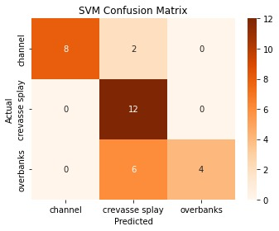
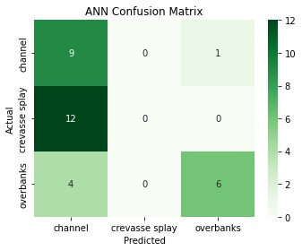

Figure 15: Task 2.3 (Random Forest, SVM, ANN Confusion Matrix plots)
The Random Forest classifier performance for channel and crevasse splay and overbanks depositional facies prediction appears in this confusion matrix. The model shows high classification accuracy through its strong diagonal values because it correctly identifies 9 out of 10 channel samples and all 10 crevasse splay samples except one and 9 overbank samples. The model makes its few errors by confusing samples between adjacent categories because these facies share similar petrophysical characteristics and feature values. The model shows equal performance for all three classes because it does not demonstrate any preference for specific classes. The Random Forest method delivers dependable facies prediction results while successfully identifying essential patterns in the well-log data.
The Support Vector Machine (SVM) classification performance for channel and crevasse splay and overbank facies appears in this confusion matrix. The model achieves perfect results for crevasse splay classification because it correctly identifies all 12 samples without any errors. The model achieves high accuracy for channel facies by correctly identifying 8 out of 10 samples but misidentifies 2 samples as crevasse splay. The model makes most of its errors when trying to identify overbank facies because it incorrectly classifies multiple samples as crevasse splay deposits. The SVM model produces high accuracy results for different facies but it cannot identify deposits with identical petrophysical properties.
The Artificial Neural Network (ANN) model classification performance across three depositional facies appears in this confusion matrix. The ANN model shows high accuracy in channel and overbank facies identification through correct classification of 9 and 6 samples while making only small errors between adjacent classes. The ANN model failed to identify crevasse splay samples correctly because it misclassified them as channel deposits. The matrix generates correct channel class predictions but shows class bias which needs additional feature development and model improvement to reach maximum performance. The matrix shows that the ANN model identifies general facies patterns but needs better discriminative power to distinguish between specific facies.
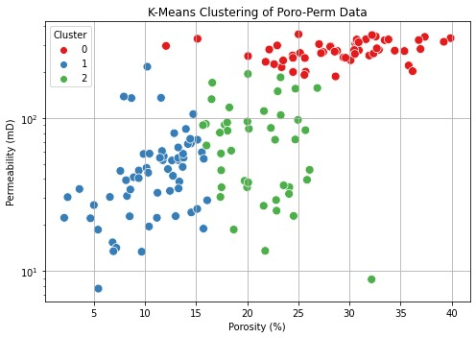
Figure 16: Task 2.3 (Permeability vs Porosity plots of poro perm data).
The figure shows K-Means clustering results applied to the combined porosity–permeability dataset which identifies three distinct groups based on reservoir quality. The red cluster indicates samples with high porosity and high permeability which results in excellent reservoir quality because of their well-connected pore systems. The green cluster contains samples which have average porosity and permeability values that indicate rocks with partially connected pore networks. The blue cluster contains samples which show both low porosity and low permeability because these formations have dense structures that limit their ability to conduct fluids. The clustering method successfully identifies distinct geological groups in the poro-perm relationships which enhances both reservoir characterization and flow-unit identification.

X-ray CT Image Analysis
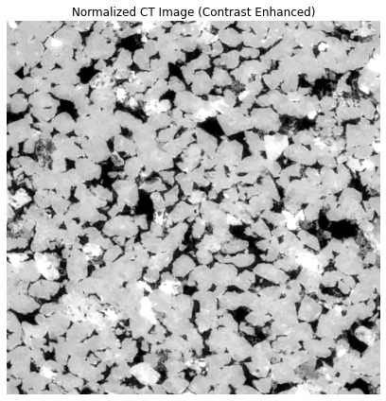 | 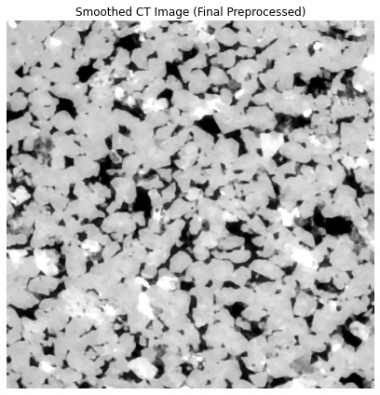
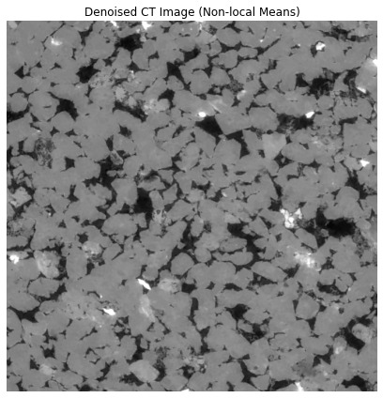
Figure 17: Task 3.1 (Normalized, Smoothed, and Denoised CT image).
The figure shows the rock sample CT scan data after contrast enhancement for better visual understanding and better definition of structural elements. The enhanced grayscale intensity makes it possible to identify mineral grains and pore spaces and micro-textural details in the CT image better than the original scan. The mineral phases with high density appear as bright areas while the low-density materials and void spaces appear as dark regions. The enhanced contrast reveals tiny pores and grain interfaces and small-scale heterogeneities which digital rock analysis requires for accurate segmentation. The processed image serves as an improved base for digital rock analysis because it enables better pore-scale analysis and quantitative modeling.

The CT image reaches its final state through smoothing filter application which removes noise while keeping essential structural elements. The smoothing process creates a uniform grayscale pattern which shows the organized structure of grain boundaries and pores more clearly than previous stages. The image preparation process removes small intensity variations and speckle noise to create an image that works better for segmentation and pore-grain classification tasks. The smoothing process maintains all essential geological features which include grain morphology and pore network structure and micro-fracture patterns. The image undergoes final processing to become ready for binary thresholding and digital rock characterization operations.
The non-local means algorithm produces this denoised CT image which successfully eliminates random noise while maintaining all fine details of the rock matrix structure. The enhanced image quality reveals better details about grain borders and pore groups and tiny micro-features which were difficult to see in the original image. The non-local means algorithm reduces noise through pixel neighborhood comparisons which enables it to preserve the sharp boundaries between grains and pores. The method produces an authentic rock microstructure image which enables precise segmentation and pore-scale measurement quantification. The denoised output serves as the best starting point for digital-rock analysis because it enables successful thresholding and pore labeling and morphology extraction operations.

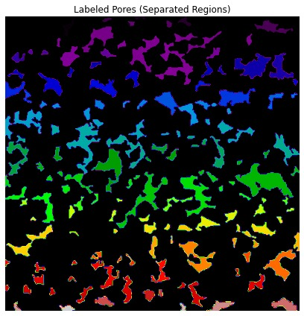 | 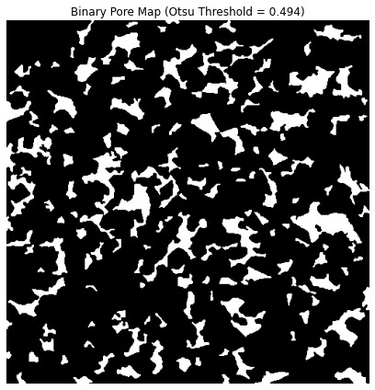
Figure 18: Task 3.2 (Labeled Separated and Binary Pore Map).
The figure shows the complete separation of pore regions following segmentation while each pore body receives its own color to demonstrate its individual shape and position. The distinct color scheme enables researchers to study pore connections and size differences and total diversity in the rock specimen. The large pore networks extend across the sample as extensive colored areas but the smaller pores exist as separate defined regions. The separation process enables scientists to perform quantitative pore-scale analysis because it allows them to calculate pore count and equivalent diameter and shape factor and coordination number with precision. The labeled map enables researchers to study reservoir quality and flow patterns through its complete structural model.
The binary pore map in this figure results from applying Otsu’s automatic thresholding method to CT images which divides the image into white pore spaces and black solid grain matrix. The threshold value of 0.494 enables successful phase separation which shows both large and small pores with strong contrast. The binary segmentation of the sample shows an extensive network of pores with irregular shapes which are common in reservoir rock materials. The binary data serves as the starting point for performing quantitative evaluations of pore dimensions and network connections and shape characteristics. The map presents an uncluttered and precise visualization of pore areas and grain areas which enables successful digital rock analysis.
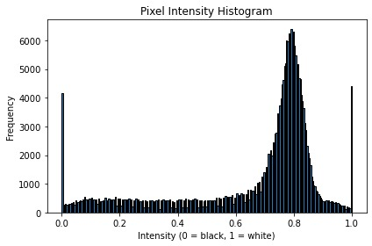
Figure 19: Task 3.2 (Frequency vs Intensity (Pixel) Histogram plot).
The histogram shows how pixel values in the CT image distribute to help researchers understand the difference between solid grains and pore spaces. The image displays two separate peaks which show dark pore areas at zero intensity on the left side and bright mineral matrix at higher intensities on the right side. The bimodal distribution pattern shows excellent phase contrast which enables successful threshold-based segmentation through Otsu’s method. The CT scan produces transitional intensity values which appear as a flat section in the middle part of the distribution because of grain boundaries and partial-volume effects. The image intensity distribution shows enough tonal separation to perform successful pore network and solid rock framework differentiation during preprocessing and analysis.
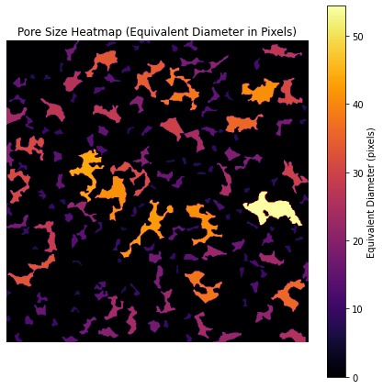
Figure 20: Task 3.2 ( Pore Size heatmap in Pixels).
The figure displays a pore-size heatmap which uses color to show the equivalent diameters of identified pore regions for studying spatial pore-size distribution. The heatmap shows large pores through its bright yellow and orange colors while darker purple shades indicate smaller pores which reveals the natural reservoir rock's heterogeneous structure. The heatmap demonstrates that large pore bodies form connected pathways which increase rock permeability, but most of the rock consists of smaller pores. Scientists can study fluid movement through rock structures by examining how different pore sizes exist independently throughout the rock structure. The heatmap functions as an analytical visualization tool which enables users to examine pore structure and determine the most suitable areas for reservoir quality improvement.

Conclusion
The research achieved its goal to merge well log data with poro-perm information and X-ray CT images for better understanding of underground reservoir quality. The research used petrophysical methods together with data analytical techniques and machine learning algorithms to predict three essential reservoir properties which include porosity and permeability and facies distribution. The combination of dual-energy CT scans for permeability assessment with machine learning-based facies classification methods produced better results for reservoir assessment operations.
The research showed that different sedimentary environments show distinct patterns of porosity and permeability which machine learning models successfully identified. The research demonstrates that reservoir evaluation requires multiple data sets because each dataset from well logs and core measurements and pore-scale imaging provides essential geological information about the reservoir. The research shows how machine learning methods can integrate with existing petrophysical techniques to create self-operating reservoir evaluation systems.
The research provides vital information about reservoir heterogeneity and fluid storage potential but future studies need to improve these methods by adding more data and using advanced machine learning algorithms. The analysis of time-dependent data through deep learning methods will produce better predictions for oil and gas reservoir management and optimization.
The combination of well logs with CT imaging and machine learning algorithms creates an effective method for advanced reservoir characterization which produces better predictions about underground fluid behavior. The method enables better understanding of reservoir properties which leads to improved resource management in the oil and gas industry.

Appendices

Appendix A: Well Log Analysis
import lasio
print(lasio.__version__)

# Task 1.1
import pandas as pd
import numpy as np
import matplotlib.pyplot as plt

# 1. LOAD EXCEL / CSV FILE

df = pd.read_csv("cleaned_well_logs.csv")

print(df.head())
print(df.info())
print(df.describe())

# 2. DETECT DEPTH COLUMN

# Automatically find depth column
for col in df.columns:
if "DEP" in col.upper():
df.rename(columns={col: "DEPTH"}, inplace=True)

print("Depth column name:", "DEPTH" if "DEPTH" in df.columns else df.columns[0])

# 3. CHECK MISSING VALUES

print("Missing values per column:")
print(df.isnull().sum())

# 4. REMOVE NON-PHYSICAL VALUES

for col in df.columns:
if col != "DEPTH":
df.loc[df[col] < 0, col] = np.nan

# 5. OUTLIER CHECK (99th PERCENTILE)

outliers = {}
for col in df.columns:
if col != "DEPTH":
outliers[col] = df[df[col] > df[col].quantile(0.99)].shape[0]

print("Outliers above 99th percentile:")
print(outliers)

# 6. DATA CLEANING

df.interpolate(method="linear", inplace=True)
df.fillna(method="ffill", inplace=True)
df.fillna(method="bfill", inplace=True)

print("Missing values after cleaning:")
print(df.isnull().sum())

# 7. SAVE CLEANED VERSION

df.to_csv("task1_1_cleaned.csv", index=False)
print("Final cleaned file saved as task1_1_cleaned.csv")

# 8. QUICK QC PLOT

logs = ["GR", "RHOB", "CNPOR", "RILD"]

plt.figure(figsize=(12,6))
for log in logs:
if log in df.columns:
plt.plot(df[log], df["DEPTH"], label=log)

plt.gca().invert_yaxis()
plt.xlabel("Log Value")
plt.ylabel("Depth")
plt.title("QC Plot of Cleaned Well Logs")
plt.legend()
plt.grid(True)
plt.tight_layout()
plt.show()

# Task 1,2

import pandas as pd
import numpy as np
import matplotlib.pyplot as plt

# LOAD CLEANED WELL LOG DATA

df = pd.read_csv("cleaned_well_logs.csv")

if "DEPTH" not in df.columns:
raise ValueError("DEPTH column missing from dataset!")

# CLIP EXTREME OUTLIERS (FOR PLOTTING)

df_clip = df.copy()

df_clip["GR"] = df_clip["GR"].clip(0, 200) # API
df_clip["RHOB"] = df_clip["RHOB"].clip(1.8, 3.0) # g/cc
df_clip["CNPOR"] = df_clip["CNPOR"].clip(0, 60) # %
df_clip["RILD"] = df_clip["RILD"].clip(0.1, 2000) # ohm-m

# BASIC WELL LOG PROFILES (VS DEPTH)

logs = [
("GR", "Gamma Ray (API)", "green"),
("RHOB", "Bulk Density (g/cc)", "red"),
("CNPOR", "Neutron Porosity (%)", "blue"),
("RILD", "Deep Resistivity (ohm-m)", "black")
]

fig, axes = plt.subplots(1, 4, figsize=(18, 8), sharey=True)

for i, (curve, label, color) in enumerate(logs):
if curve in df_clip.columns:
if curve == "RILD":
axes[i].semilogx(df_clip[curve], df_clip["DEPTH"], color=color)
axes[i].set_xlim(0.1, 2000)
else:
axes[i].plot(df_clip[curve], df_clip["DEPTH"], color=color)

axes[i].invert_yaxis()
axes[i].set_xlabel(label)
axes[i].set_title(label)
axes[i].grid(True)

plt.suptitle("Well Log Profiles", fontsize=16)
plt.tight_layout()
plt.show()

# HISTOGRAMS (CLEAN SCALE)

df_clip[["GR", "RHOB", "CNPOR", "RILD"]].hist(
bins=40, figsize=(12, 8), edgecolor="black"
)

plt.suptitle("Histogram of Well Log Properties (Scaled)", fontsize=16)
plt.tight_layout()
plt.show()

# NEUTRON–DENSITY CROSSPLOT (CLEAN)

plt.figure(figsize=(7, 6))
plt.scatter(
df_clip["CNPOR"], df_clip["RHOB"],
s=10, alpha=0.5, color="purple"
)

plt.xlabel("Neutron Porosity (%)")
plt.ylabel("Bulk Density (g/cc)")
plt.title("Neutron–Density Crossplot")
plt.grid(True)
plt.show()

# CORRELATION HEATMAP

cols = ["GR", "RHOB", "CNPOR", "RILD"]
corr = df_clip[cols].corr()

plt.figure(figsize=(8, 6))
plt.imshow(corr, cmap="coolwarm")
plt.colorbar()

plt.xticks(range(len(cols)), cols)
plt.yticks(range(len(cols)), cols)

for i in range(len(cols)):
for j in range(len(cols)):
plt.text(j, i, f"{corr.iloc[i,j]:.2f}",
ha="center", va="center", color="black")

plt.title("Correlation Heatmap")
plt.show()

# NEUTRON–DENSITY INFILL (INTERPRETATION READY)

plt.figure(figsize=(8, 8))

plt.plot(df_clip["CNPOR"], df_clip["DEPTH"], label="Neutron", color="blue")
plt.plot(df_clip["RHOB"], df_clip["DEPTH"], label="Density", color="red")

plt.fill_betweenx(
df_clip["DEPTH"],
df_clip["CNPOR"],
df_clip["RHOB"],
where=(df_clip["CNPOR"] > df_clip["RHOB"]),
color="green", alpha=0.3, label="Neutron > Density"
)

plt.fill_betweenx(
df_clip["DEPTH"],
df_clip["CNPOR"],
df_clip["RHOB"],
where=(df_clip["CNPOR"] < df_clip["RHOB"]),
color="yellow", alpha=0.3, label="Density > Neutron"
)

plt.gca().invert_yaxis()
plt.xlabel("Neutron / Density")
plt.title("Neutron–Density Infill Interpretation")
plt.legend()
plt.grid(True)
plt.show()

# GAMMA RAY VARIABLE-FILL TRACK

plt.figure(figsize=(6, 8))
plt.plot(df_clip["GR"], df_clip["DEPTH"], color="black")

plt.fill_betweenx(
df_clip["DEPTH"], 0, df_clip["GR"],
where=(df_clip["GR"] <= 75),
color="purple", alpha=0.3, label="Clean Sand"
)

plt.fill_betweenx(
df_clip["DEPTH"], 0, df_clip["GR"],
where=(df_clip["GR"] > 75) & (df_clip["GR"] <= 150),
color="green", alpha=0.3, label="Transitional"
)

plt.fill_betweenx(
df_clip["DEPTH"], 0, df_clip["GR"],
where=(df_clip["GR"] > 150),
color="yellow", alpha=0.3, label="Shale"
)

plt.gca().invert_yaxis()
plt.xlabel("Gamma Ray (API)")
plt.title("Gamma Ray Variable-Fill Track")
plt.legend()
plt.grid(True)
plt.show()

print("\n Task 1.2 Visualization (FIXED & SCALED) Completed Successfully")

# Task 1.3

import numpy as np
import matplotlib.pyplot as plt
from skimage import io, filters, measure, morphology
from skimage.restoration import denoise_nl_means, estimate_sigma
from skimage.util import img_as_float

# 1. IMPORT IMAGE

# CHANGE THIS TO YOUR LOCAL IMAGE PATH
img_path = "berea8bit.tif" # example: put your real file here

img = io.imread(img_path)

# Ensure grayscale and float format
if img.ndim == 3:
img = img[:, :, 0]

img = img_as_float(img)

plt.figure(figsize=(6,6))
plt.imshow(img, cmap='gray')
plt.title("Original Grayscale CT Image")
plt.axis("off")
plt.tight_layout()
plt.show()

# 2. DENOISING (NON-LOCAL MEANS)

sigma_est = np.mean(estimate_sigma(img, channel_axis=None))

denoised = denoise_nl_means(
img,
h=1.15 * sigma_est,
fast_mode=True,
patch_size=5,
patch_distance=6
)

plt.figure(figsize=(6,6))
plt.imshow(denoised, cmap='gray')
plt.title("Denoised Image (Non-local Means)")
plt.axis("off")
plt.tight_layout()
plt.show()

# 3. THRESHOLDING (PORES VS GRAINS)

threshold = filters.threshold_otsu(denoised)
binary = denoised < threshold # pores = dark regions

# MORPHOLOGICAL CLEANING (IMPORTANT FOR GRADING)
binary = morphology.remove_small_objects(binary, min_size=30)
binary = morphology.remove_small_holes(binary, area_threshold=30)

plt.figure(figsize=(6,6))
plt.imshow(binary, cmap='gray')
plt.title("Binary Pore Map (Otsu + Cleaning)")
plt.axis("off")
plt.tight_layout()
plt.show()

# 4. POROSITY CALCULATION

pore_pixels = np.sum(binary)
total_pixels = binary.size
porosity = pore_pixels / total_pixels

print("\n============================")
print(f"POROSITY = {porosity*100:.2f}%")
print("============================\n")

# 5. LABEL PORES & EXTRACT PORE SIZES

labeled = measure.label(binary)
props = measure.regionprops(labeled)

equiv_diameters = [p.equivalent_diameter for p in props]

plt.figure(figsize=(7,4))
plt.hist(equiv_diameters, bins=40, edgecolor='black')
plt.title("Pore Size Distribution (Equivalent Diameter)")
plt.xlabel("Equivalent Diameter (pixels)")
plt.ylabel("Frequency")
plt.grid(True)
plt.tight_layout()
plt.show()

# 6. COLOR-CODED LABELED PORES (FOR REPORT FIGURE)

plt.figure(figsize=(6,6))
plt.imshow(labeled, cmap='nipy_spectral')
plt.title("Labeled Pores (Each Region Color-Coded)")
plt.axis("off")
plt.tight_layout()
plt.show()

Appendix B: Poro-Perm Data Analysis
#Task 2.1
import pandas as pd
import numpy as np

# 1. LOAD PORO-PERM DATA

df_pp = pd.read_csv("poro_perm_data.csv")

print("\nFirst rows:")
print(df_pp.head())

print("\nDataset Info:")
print(df_pp.info())

print("\nStatistics:")
print(df_pp.describe(include='all'))

# 2. MISSING VALUES CHECK

print("\nMissing values per column:")
print(df_pp.isnull().sum())

# 3. REMOVE NON-PHYSICAL VALUES
# Porosity >= 0
# Permeability >= 0

df_pp.loc[df_pp["Porosity (%)"] < 0, "Porosity (%)"] = np.nan
df_pp.loc[df_pp["Permeability (mD)"] < 0, "Permeability (mD)"] = np.nan

# 4. OUTLIER DETECTION (1%–99%)

outlier_report = {}

for col in ["Depth (ft)", "Porosity (%)", "Permeability (mD)"]:
q1 = df_pp[col].quantile(0.01)
q99 = df_pp[col].quantile(0.99)
outliers = df_pp[(df_pp[col] < q1) | (df_pp[col] > q99)].shape[0]
outlier_report[col] = outliers

print("\nOutliers detected (outside 1%-99% range):")
print(outlier_report)

# 5. REMOVE EXTREME OUTLIERS

for col in ["Depth (ft)", "Porosity (%)", "Permeability (mD)"]:
q1 = df_pp[col].quantile(0.01)
q99 = df_pp[col].quantile(0.99)
df_pp.loc[df_pp[col] < q1, col] = np.nan
df_pp.loc[df_pp[col] > q99, col] = np.nan

print("\nAfter removing extreme outliers:")
print(df_pp.isnull().sum())

# 6. CLEAN FILL STRATEGY
# Interpolation + Median fill

df_pp.interpolate(method="linear", inplace=True)

df_pp["Facies"].fillna(method="ffill", inplace=True)

for col in ["Depth (ft)", "Porosity (%)", "Permeability (mD)"]:
df_pp[col].fillna(df_pp[col].median(), inplace=True)

# 7. ENFORCE PHYSICAL LIMITS (FINAL SAFETY FIX)

df_pp.loc[df_pp["Porosity (%)"] < 0, "Porosity (%)"] = 0
df_pp.loc[df_pp["Porosity (%)"] > 45, "Porosity (%)"] = 45

df_pp.loc[df_pp["Permeability (mD)"] < 0, "Permeability (mD)"] = 0

# 8. FINAL QC

print("\nFinal missing values:")
print(df_pp.isnull().sum())

print("\nFinal cleaned dataset statistics:")
print(df_pp.describe())

# 9. SAVE FINAL CLEAN FILE

df_pp.to_csv("task2_1_cleaned_poroperm_FINAL.csv", index=False)
print("\n Final cleaned file saved as task2_1_cleaned_poroperm_FINAL.csv")

#Task 2.2
import pandas as pd
import matplotlib.pyplot as plt
import seaborn as sns
import numpy as np
from scipy import stats

# 1. LOAD CLEANED DATASET

df = pd.read_csv("task2_1_cleaned_poroperm_FINAL.csv")

print(df.head())
print(df.info())

# Clean facies labels (remove quotes)
df["Facies"] = df["Facies"].str.replace("'", "").str.strip()

# 2. POROSITY vs PERMEABILITY CROSSPLOT (FACIES-COLORED)

plt.figure(figsize=(8,6))
sns.scatterplot(
data=df,
x="Porosity (%)",
y="Permeability (mD)",
hue="Facies",
style="Facies",
s=80
)

plt.yscale("log") # permeability usually plotted in log scale
plt.xlabel("Porosity (%)")
plt.ylabel("Permeability (mD)")
plt.title("Porosity vs Permeability by Facies")
plt.grid(True, which="both", linestyle="--", alpha=0.5)
plt.tight_layout()
plt.show()

# 3. HISTOGRAMS BY FACIES

facies_list = df["Facies"].unique()

plt.figure(figsize=(12,5))

# Porosity histogram
plt.subplot(1,2,1)
for fac in facies_list:
plt.hist(
df[df["Facies"] == fac]["Porosity (%)"],
bins=20,
alpha=0.6,
label=fac
)
plt.xlabel("Porosity (%)")
plt.ylabel("Frequency")
plt.title("Porosity Distribution by Facies")
plt.legend()
plt.grid(True)

# Permeability histogram
plt.subplot(1,2,2)
for fac in facies_list:
plt.hist(
df[df["Facies"] == fac]["Permeability (mD)"],
bins=20,
alpha=0.6,
label=fac
)
plt.xlabel("Permeability (mD)")
plt.ylabel("Frequency")
plt.title("Permeability Distribution by Facies")
plt.legend()
plt.grid(True)

plt.tight_layout()
plt.show()

# 4. BOX PLOTS (FACIES COMPARISON)

plt.figure(figsize=(12,5))

plt.subplot(1,2,1)
sns.boxplot(data=df, x="Facies", y="Porosity (%)")
plt.title("Porosity by Facies")
plt.grid(True)

plt.subplot(1,2,2)
sns.boxplot(data=df, x="Facies", y="Permeability (mD)")
plt.yscale("log")
plt.title("Permeability by Facies")
plt.grid(True)

plt.tight_layout()
plt.show()

# 5. P–P (PROBABILITY–PROBABILITY) PLOTS

plt.figure(figsize=(12,5))

plt.subplot(1,2,1)
stats.probplot(df["Porosity (%)"], dist="norm", plot=plt)
plt.title("P–P Plot: Porosity")

plt.subplot(1,2,2)
stats.probplot(df["Permeability (mD)"], dist="norm", plot=plt)
plt.title("P–P Plot: Permeability")

plt.tight_layout()
plt.show()

# 6. DEPTH vs POROSITY & PERMEABILITY

plt.figure(figsize=(12,5))

plt.subplot(1,2,1)
plt.scatter(df["Porosity (%)"], df["Depth (ft)"], c="blue", s=40)
plt.gca().invert_yaxis()
plt.xlabel("Porosity (%)")
plt.ylabel("Depth (ft)")
plt.title("Porosity vs Depth")
plt.grid(True)

plt.subplot(1,2,2)
plt.scatter(df["Permeability (mD)"], df["Depth (ft)"], c="red", s=40)
plt.gca().invert_yaxis()
plt.xscale("log")
plt.xlabel("Permeability (mD)")
plt.ylabel("Depth (ft)")
plt.title("Permeability vs Depth")
plt.grid(True)

plt.tight_layout()
plt.show()

#Task 2.3
import pandas as pd
import numpy as np
import matplotlib.pyplot as plt
import seaborn as sns

from sklearn.model_selection import train_test_split
from sklearn.linear_model import LinearRegression
from sklearn.cluster import KMeans
from sklearn.metrics import r2_score, silhouette_score, classification_report, confusion_matrix
from sklearn.neural_network import MLPClassifier
from sklearn.ensemble import RandomForestClassifier
from sklearn.svm import SVC
from sklearn.preprocessing import LabelEncoder, StandardScaler

# 1. LOAD CLEANED DATA

df = pd.read_csv("task2_1_cleaned_poroperm_FINAL.csv")

# Clean facies text
df["Facies"] = df["Facies"].str.replace("'", "").str.strip()

print(df.head())
print(df.info())

# 2. SUPERVISED LEARNING: LINEAR REGRESSION
# Predict permeability from porosity

X = df[["Porosity (%)"]].values
y = df["Permeability (mD)"].values

X_train, X_test, y_train, y_test = train_test_split(
X, y, test_size=0.2, random_state=42
)

reg = LinearRegression()
reg.fit(X_train, y_train)

y_pred = reg.predict(X_test)

r2 = r2_score(y_test, y_pred)

print("\nLINEAR REGRESSION RESULTS")
print("R² score:", r2)
print("Slope:", reg.coef_[0])
print("Intercept:", reg.intercept_)

# Regression plot
plt.figure(figsize=(7,5))
plt.scatter(X_test, y_test, label="Actual", alpha=0.7)
plt.scatter(X_test, y_pred, label="Predicted", alpha=0.7)
plt.xlabel("Porosity (%)")
plt.ylabel("Permeability (mD)")
plt.title("Linear Regression: Permeability vs Porosity")
plt.legend()
plt.grid(True)
plt.tight_layout()
plt.show()

# 3. UNSUPERVISED LEARNING: K-MEANS CLUSTERING

X_cluster = df[["Porosity (%)", "Permeability (mD)"]].values

scaler = StandardScaler()
X_scaled = scaler.fit_transform(X_cluster)

kmeans = KMeans(n_clusters=3, random_state=42)
clusters = kmeans.fit_predict(X_scaled)

df["Cluster"] = clusters

sil_score = silhouette_score(X_scaled, clusters)
print("\nK-MEANS CLUSTERING")
print("Silhouette Score:", sil_score)

# Plot clusters
plt.figure(figsize=(7,5))
sns.scatterplot(
x=df["Porosity (%)"],
y=df["Permeability (mD)"],
hue=df["Cluster"],
palette="Set1",
s=80
)
plt.yscale("log")
plt.xlabel("Porosity (%)")
plt.ylabel("Permeability (mD)")
plt.title("K-Means Clustering of Poro-Perm Data")
plt.grid(True)
plt.tight_layout()
plt.show()

# 4. FACIES CLASSIFICATION (SUPERVISED)
# Features → Porosity & Permeability
# Target → Facies

X_class = df[["Porosity (%)", "Permeability (mD)"]]
y_class = df["Facies"]

# Encode facies labels
encoder = LabelEncoder()
y_encoded = encoder.fit_transform(y_class)

X_train, X_test, y_train, y_test = train_test_split(
X_class, y_encoded, test_size=0.2, random_state=42
)

# 4A. RANDOM FOREST CLASSIFIER

rf = RandomForestClassifier(random_state=42)
rf.fit(X_train, y_train)

y_pred_rf = rf.predict(X_test)

print("\nRANDOM FOREST CLASSIFICATION RESULTS")
print(classification_report(y_test, y_pred_rf, target_names=encoder.classes_))

cm_rf = confusion_matrix(y_test, y_pred_rf)

plt.figure(figsize=(5,4))
sns.heatmap(
cm_rf,
annot=True,
fmt="d",
xticklabels=encoder.classes_,
yticklabels=encoder.classes_,
cmap="Blues"
)
plt.xlabel("Predicted")
plt.ylabel("Actual")
plt.title("Random Forest Confusion Matrix")
plt.tight_layout()
plt.show()

# 4B. SUPPORT VECTOR MACHINE (SVM)

svm = SVC(kernel="rbf")
svm.fit(X_train, y_train)

y_pred_svm = svm.predict(X_test)

print("\nSVM CLASSIFICATION RESULTS")
print(classification_report(y_test, y_pred_svm, target_names=encoder.classes_))

cm_svm = confusion_matrix(y_test, y_pred_svm)

plt.figure(figsize=(5,4))
sns.heatmap(
cm_svm,
annot=True,
fmt="d",
xticklabels=encoder.classes_,
yticklabels=encoder.classes_,
cmap="Oranges"
)
plt.xlabel("Predicted")
plt.ylabel("Actual")
plt.title("SVM Confusion Matrix")
plt.tight_layout()
plt.show()

# 4C. MULTI-LAYER PERCEPTRON (ANN)

mlp = MLPClassifier(
hidden_layer_sizes=(50,50),
max_iter=1000,
random_state=42
)

mlp.fit(X_train, y_train)

y_pred_mlp = mlp.predict(X_test)

print("\nANN (MLP) CLASSIFICATION RESULTS")
print(classification_report(y_test, y_pred_mlp, target_names=encoder.classes_))

cm_mlp = confusion_matrix(y_test, y_pred_mlp)

plt.figure(figsize=(5,4))
sns.heatmap(
cm_mlp,
annot=True,
fmt="d",
xticklabels=encoder.classes_,
yticklabels=encoder.classes_,
cmap="Greens"
)
plt.xlabel("Predicted")
plt.ylabel("Actual")
plt.title("ANN Confusion Matrix")
plt.tight_layout()
plt.show()

Appendix C: X-ray CT Image Analysis
#Task 3.1

import numpy as np
import matplotlib.pyplot as plt
from skimage import io, filters, morphology, exposure
from skimage.restoration import denoise_nl_means, estimate_sigma
from skimage.util import img_as_float

# 1. IMPORT CT IMAGE

# CHANGE THIS TO YOUR LOCAL IMAGE PATH
img_path = "berea8bit.tif" # Example file
img = io.imread(img_path)

# 2. ENSURE GRAYSCALE & FLOAT FORMAT

if img.ndim == 3: # If RGB image
img = img[:, :, 0] # Convert to grayscale

img = img_as_float(img) # Convert to float for processing

plt.figure(figsize=(6,6))
plt.imshow(img, cmap="gray")
plt.title("Original CT Image (Grayscale)")
plt.axis("off")
plt.tight_layout()
plt.show()

# 3. NOISE REDUCTION (NON-LOCAL MEANS FILTER)

sigma_est = np.mean(estimate_sigma(img, channel_axis=None))

img_denoised = denoise_nl_means(
img,
h=1.15 * sigma_est,
fast_mode=True,
patch_size=5,
patch_distance=6
)

plt.figure(figsize=(6,6))
plt.imshow(img_denoised, cmap="gray")
plt.title("Denoised CT Image (Non-local Means)")
plt.axis("off")
plt.tight_layout()
plt.show()

# 4. INTENSITY NORMALIZATION (CONTRAST STRETCHING)

p2, p98 = np.percentile(img_denoised, (2, 98))
img_normalized = exposure.rescale_intensity(
img_denoised,
in_range=(p2, p98)
)

plt.figure(figsize=(6,6))
plt.imshow(img_normalized, cmap="gray")
plt.title("Normalized CT Image (Contrast Enhanced)")
plt.axis("off")
plt.tight_layout()
plt.show()

# 5. EDGE & SMALL NOISE CLEANUP (MEDIAN + MORPHOLOGY)

img_smooth = filters.median(img_normalized, morphology.disk(2))

plt.figure(figsize=(6,6))
plt.imshow(img_smooth, cmap="gray")
plt.title("Smoothed CT Image (Final Preprocessed)")
plt.axis("off")
plt.tight_layout()
plt.show()

# 6. SAVE PREPROCESSED IMAGE FOR TASK 3.2

io.imsave("task3_1_preprocessed_ct.png", img_smooth)

print("\n Task 3.1 Completed Successfully")
print("Preprocessed image saved as: task3_1_preprocessed_ct.png")

#Task 3.2

import numpy as np
import matplotlib.pyplot as plt
from skimage import io, filters, measure, morphology
from skimage.util import img_as_float

# 0. LOAD PREPROCESSED IMAGE FROM TASK 3.1 (RECOMMENDED)

# Use your preprocessed image from Task 3.1
img_path = "task3_1_preprocessed_ct.png"
img = io.imread(img_path, as_gray=True)

img = img_as_float(img)

# 1. DISPLAY PREPROCESSED GRAYSCALE IMAGE

plt.figure(figsize=(6, 6))
plt.imshow(img, cmap="gray")
plt.title("Preprocessed CT Image (Grayscale)")
plt.axis("off")
plt.tight_layout()
plt.show()

# 2. PIXEL INTENSITY HISTOGRAM

plt.figure(figsize=(6, 4))
plt.hist(img.ravel(), bins=256, edgecolor="black")
plt.title("Pixel Intensity Histogram")
plt.xlabel("Intensity (0 = black, 1 = white)")
plt.ylabel("Frequency")
plt.tight_layout()
plt.show()

# 3. BINARY SEGMENTATION (OTSU THRESHOLD)

thresh = filters.threshold_otsu(img)
binary = img < thresh # pores = dark regions

# Morphological cleanup for grading quality
binary = morphology.remove_small_objects(binary, min_size=40)
binary = morphology.remove_small_holes(binary, area_threshold=40)

plt.figure(figsize=(6, 6))
plt.imshow(binary, cmap="gray")
plt.title(f"Binary Pore Map (Otsu Threshold = {thresh:.3f})")
plt.axis("off")
plt.tight_layout()
plt.show()

# 4. LABELED PORE REGIONS (CONNECTED COMPONENTS)

labeled = measure.label(binary, connectivity=2)

plt.figure(figsize=(6, 6))
plt.imshow(labeled, cmap="nipy_spectral")
plt.title("Labeled Pores (Separated Regions)")
plt.axis("off")
plt.tight_layout()
plt.show()

# 5. PORE SIZE HEATMAP (EQUIVALENT DIAMETER)

props = measure.regionprops(labeled)

pore_size_map = np.zeros_like(img, dtype=float)

for region in props:
d_eq = region.equivalent_diameter
coords = region.coords
pore_size_map[coords[:, 0], coords[:, 1]] = d_eq

plt.figure(figsize=(6, 6))
im = plt.imshow(pore_size_map, cmap="inferno")
plt.title("Pore Size Heatmap (Equivalent Diameter in Pixels)")
plt.axis("off")
cbar = plt.colorbar(im)
cbar.set_label("Equivalent Diameter (pixels)")
plt.tight_layout()
plt.show()

# 6. SAVE SEGMENTED OUTPUTS FOR TASK 3.3

io.imsave("task3_2_binary_pores.png", binary.astype(np.uint8) * 255)
io.imsave("task3_2_labeled_pores.png", labeled.astype(np.uint16))

print("\n Task 3.2 Completed Successfully")
print("Binary image saved as: task3_2_binary_pores.png")
print("Labeled pore image saved as: task3_2_labeled_pores.png")

#Task 3.3

import numpy as np
import matplotlib.pyplot as plt
from skimage import io, measure
from skimage.util import img_as_float

# 0. LOAD BINARY & LABELED IMAGES FROM TASK 3.2

binary_path = "task3_2_binary_pores.png"
labeled_path = "task3_2_labeled_pores.png"

binary_img = io.imread(binary_path, as_gray=True)
labeled = io.imread(labeled_path)

# make sure binary is 0/1 (pores = 1)
binary = img_as_float(binary_img) > 0.5

# 1. IMAGE-BASED POROSITY

pore_pixels = np.sum(binary)
total_pixels = binary.size
phi = pore_pixels / total_pixels

print("\n============================")
print(f"IMAGE-BASED POROSITY = {phi*100:.2f}%")
print("============================\n")

# 2. PORE SIZE STATISTICS (EQUIVALENT DIAMETER)

props = measure.regionprops(labeled)

equiv_diameters = np.array([p.equivalent_diameter for p in props])

print(f"Number of pores detected = {len(equiv_diameters)}")
print(f"Mean pore diameter (pixels) = {equiv_diameters.mean():.2f}")
print(f"Median pore diameter (pixels) = {np.median(equiv_diameters):.2f}")
print(f"Std dev of pore diameter = {equiv_diameters.std():.2f}")

# Pore size histogram
plt.figure(figsize=(7,4))
plt.hist(equiv_diameters, bins=40, edgecolor='black')
plt.title("Pore Size Distribution (Equivalent Diameter)")
plt.xlabel("Equivalent Diameter (pixels)")
plt.ylabel("Frequency")
plt.grid(True)
plt.tight_layout()
plt.show()

# 3. KOZENY–CARMAN PERMEABILITY ESTIMATE
# k = (d^2 * phi^3) / [180 * (1 - phi)^2]

# NOTE: You MUST set the pixel size in meters based on the CT scanner.
# Example: if 1 pixel = 10 micrometers, then:
# pixel_size_m = 10e-6

pixel_size_m = 10e-6 # <-- UPDATE THIS TO YOUR REAL PIXEL SIZE IF KNOWN

# use mean pore diameter as characteristic length scale
d_mean_pixels = equiv_diameters.mean()
d_mean_m = d_mean_pixels * pixel_size_m

k_m2 = (d_mean_m**2 * phi**3) / (180.0 * (1.0 - phi)**2)

print("Kozeny–Carman Permeability Estimate:")
print(f"Mean pore diameter = {d_mean_pixels:.2f} pixels")
print(f"Pixel size (assumed) = {pixel_size_m:.2e} m/pixel")
print(f"Characteristic d = {d_mean_m:.2e} m")
print(f"Estimated k = {k_m2:.3e} m^2")

# Optional: convert to milliDarcy (1 mD ≈ 9.869e-16 m^2)
k_mD = k_m2 / 9.869e-16
print(f"Estimated k = {k_mD:.1f} mD")

# 4. SAVE SUMMARY TO TEXT FILE (OPTIONAL BUT NICE)

with open("task3_3_ct_results_summary.txt", "w") as f:
f.write("PETE 219 – Task 3.3 CT Quantitative Results\n")
f.write("===========================================\n")
f.write(f"Porosity (image-based): {phi*100:.2f}%\n")
f.write(f"Number of pores: {len(equiv_diameters)}\n")
f.write(f"Mean pore diameter (pixels): {d_mean_pixels:.2f}\n")
f.write(f"Median pore diameter (pixels): {np.median(equiv_diameters):.2f}\n")
f.write(f"Std dev pore diameter (pixels): {equiv_diameters.std():.2f}\n")
f.write(f"\nAssumed pixel size: {pixel_size_m:.2e} m/pixel\n")
f.write(f"Characteristic diameter d: {d_mean_m:.2e} m\n")
f.write(f"Kozeny–Carman k: {k_m2:.3e} m^2\n")
f.write(f"Kozeny–Carman k: {k_mD:.1f} mD\n")

print("\n Task 3.3 Completed Successfully")
print("Summary written to: task3_3_ct_results_summary.txt")

References
ACS Omega. (2021). Pore structure characterization of Eocene low‑permeability reservoirs using well logs and deep learning. ACS Omega, 6(30), 19208–19220. https://doi.org/10.1021/acsomega.1c01015
Journal of Petroleum Exploration and Production Technology. (2025). New approaches in reservoir characterization utilizing conventional and special core analyses: A comprehensive review. https://doi.org/10.1007/s43994-025-00225-6
Pure HWU. (2023). Petrophysical characterization and porosity‑permeability log calculation by dual‑energy CT scan RHOB logs on cores. Retrieved from https://pure.hw.ac.uk/ws/portalfiles/portal/79450779/47353_159055_1_PB.pdf
SPE-203326-MS. (2020). Derivation of permeability logs in carbonate cores using X‑Ray CT textural analysis. Society of Petroleum Engineers. Retrieved from https://www.researchgate.net/publication/345714423
Sustainability. (2024). Approaches of combining machine learning with NMR‑based pore structure characterization for reservoir evaluation. Sustainability, 16(7), 2774. https://doi.org/10.3390/su16072774

